Seeding

## Cotton Seed Planter

**Category:** Planting Implement

**Tag:** Tractor Mounted Planting / Seeding implement

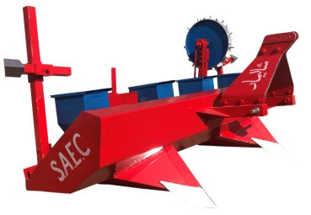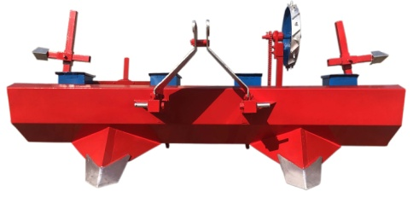

Tractor Mounted Implement for Sowing of Seeds in-line on Raised Beds

## Description

* Drops one Seed at a time no missing, no doubling.
* Saving of Costly Seed.
* No Damage to Seed during sowing operation.
* Precision in sowing can increase the yield from 10% to 15%.
* Uniform depth of sowing - better stand, better growth of roots, no waviness - better yield.
* Labour Saving - reduced cost of planting (Scarce & Costly Labour)
* High Planting speed hence high output
* Appropriate and uniform spacing between Seed and Fertilizer for the good growth of plant & for high yield

|  |  |  |  |
| --- | --- | --- | --- |
| Specifications | | | |
|  | Manual Seeding | Seed Only | Seed & Fertilizer |
| Width | 108'' | | |
| Length | 50'' | | |
| Height | 42'' | | |
| Seed Row Spacing | 24'' - 27'' - 30'' | | |
| Linkage | Three Points | | |
| Bed Planting Tynes | 2 | | |
| Rows | 4 & 6 | | |
| Seed Hooper Capacity | 0 | 100 KG | |
| No. of Boxes | 0 | 4 | 8 |
| Seed Rate | Adjustable | | |
| Mechanism | Wheel (Steel) | | |
| Tractor Compatibility | 60 HP | 65 HP | 1. P |

## Potato Planter

**Category:** Planting Implement

**Tag:** Tractor Mounted Planting / Seeding implement

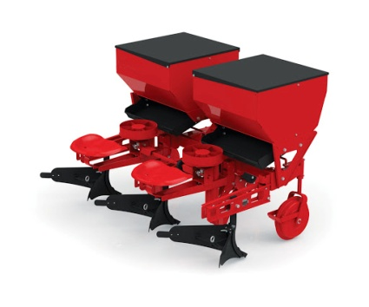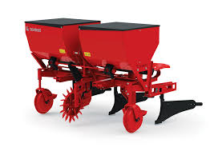

## Description

The potato planter is multifunctional machine that ditch and fertilize, finishing the complete process of sowing, ridge forming and planting. It can be used for different areas, climates and soils. Our machine has the features of compact structure, superior mobility and simple maintenance.

Shalimar potato planter is planned for automatic two- four row planting. It can plant almost all size of potato seeds and can also plant cut seeds. The planting operation movement is visible thus it avoids missing. Two row automatic planter can plant 5-6 acres and four row can plant 10-12 acres per day.

|  |  |
| --- | --- |
| Specifications | |
| Capacity | 4-12 acres/day |
| Material | Steel |
| Seed Tank Capacity | 0.4m³ |
| Linkage | Three Points |
| Row Spacing | 16'' - 29'' |
| Planting Distance | 10'' - 13'' |
| Manure Tank | Optional |
| Tractor Compatibility | * 1. P |

## Wheat seed drill

**Category:** Planting Implement

**Tag:** Tractor Mounted Planting / Seeding implement

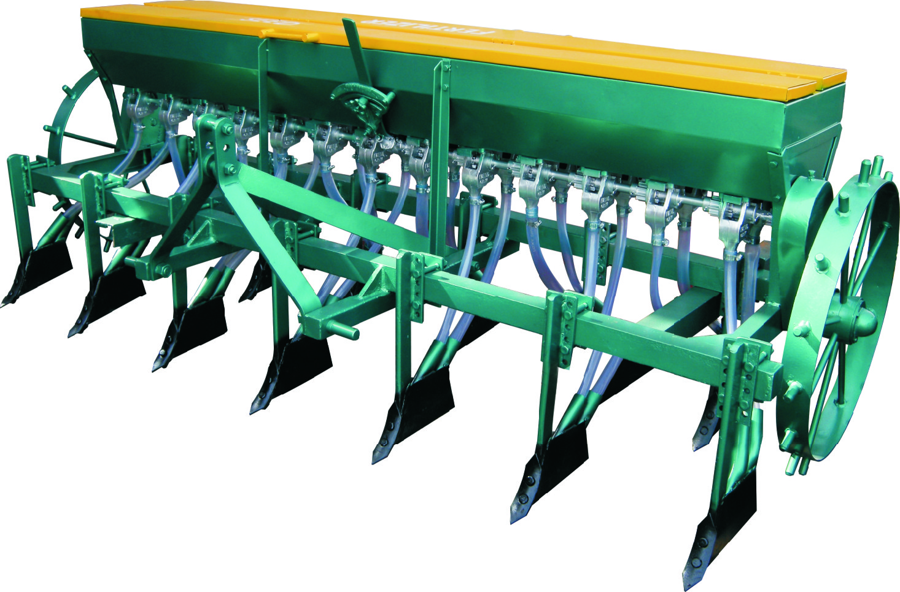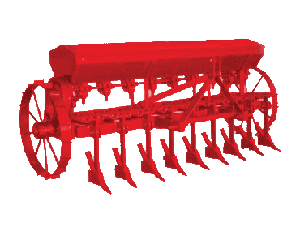

## Description

* This seed drill is used for seeding of wheat primarily and other different seeds such as Sunflower, Soya bean, Grams and Cotton Seeds by doing small changes in drop units. It also maintains plants to plant spacing in a row
* Seeding and Fertilization simultaneously in single pass
* Increases yield by 10%
* 100-120 KG Seed Capacity

|  |  |  |
| --- | --- | --- |
| Specifications | | |
|  | 13 Rows | 15 Rows |
| Width | 96'' | 112'' |
| Length | 52'' | |
| Height | 46'' | |
| Row Spacing (adjustable) | 4 - 6'' | |
| Linkage | Three Points | |
| Drop Units | 26 | 30 |
| Seeding Depth | 3'' | |
| Seed Rate | Adjustable | |
| Seed Hooper Capacity | 100 KG | 120 KG |
| Mechanism | Wheel (Steel) | |
| Tractor Compatibility | 50 HP | 60HP |

## Zero Tillage Seed Drill

**Category:** Planting Implement

**Tag:** Tractor Mounted Planting / Seeding

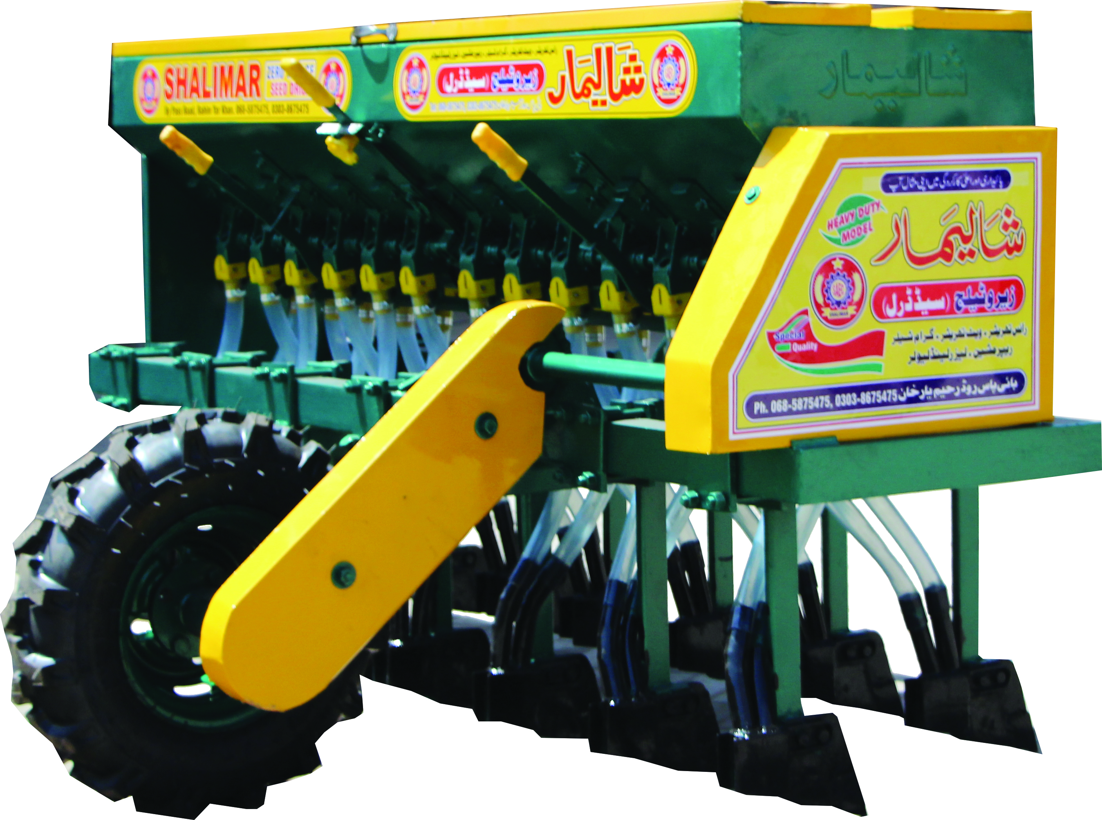 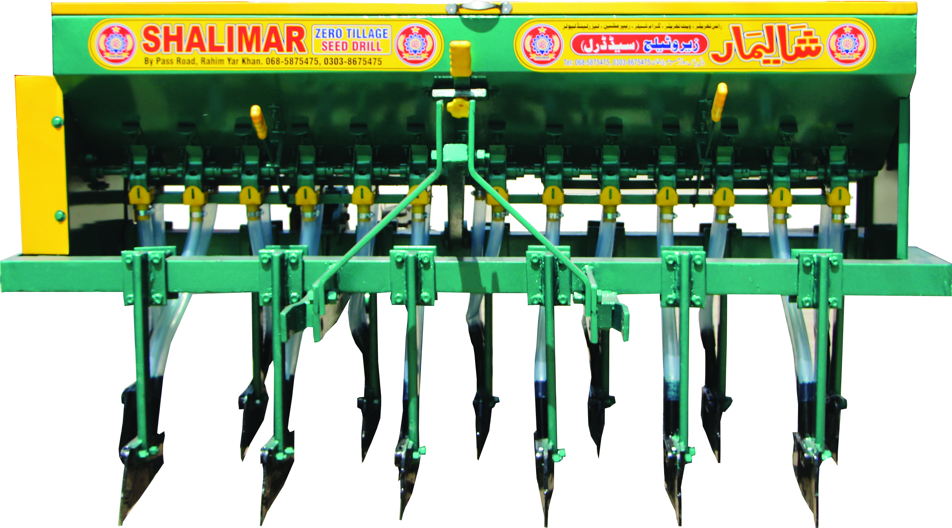

For Sowing Wheat in Fields Containing Wheat/Rice Stubbles.

## Description

The zero till consists of a seed box, fertilizer box, seed and fertilizer metering mechanisms, seed tubes, furrow openers, seed and fertilizer rate adjusting lever. The length of the grooves exposed to the seed, can be increased or decreased and hence the amount of seed sown can be varied. It made from heavy structure and gauge sheets. It contains adjustable flow of fertilizer through knob.

|  |  |  |
| --- | --- | --- |
| Specifications | | |
|  | 13 Rows | 15 Rows |
| Width | 87’’ | 111’’ |
| Length | 55’’ | |
| Height | 46'' | |
| Row Spacing (adjustable) | 6'' | |
| Fertilizer tank | 100 kg | 120 kg |
| Seed tank | 100 kg | 120 kg |
| Max. Working depth | 3’’ | 3’’ |
| Drop Units | 26 | 30 |
| Weight | 424 KG | 515 KG |
| Tractor Compatibility | 50 HP | 60 HP |